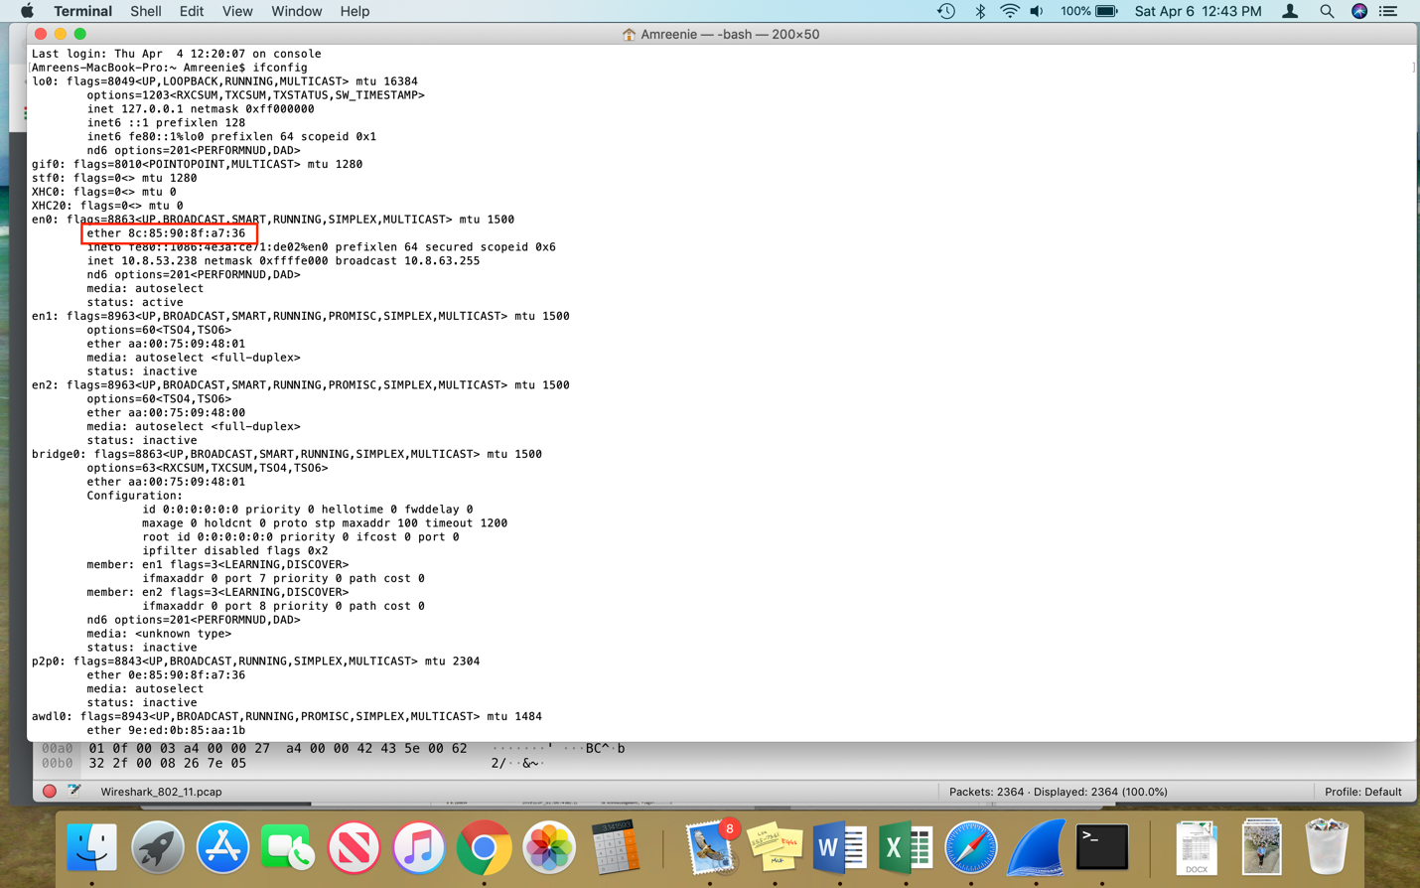

1. What are the SSIDs of the two access points that are issuing most of the beacon frames in this trace?

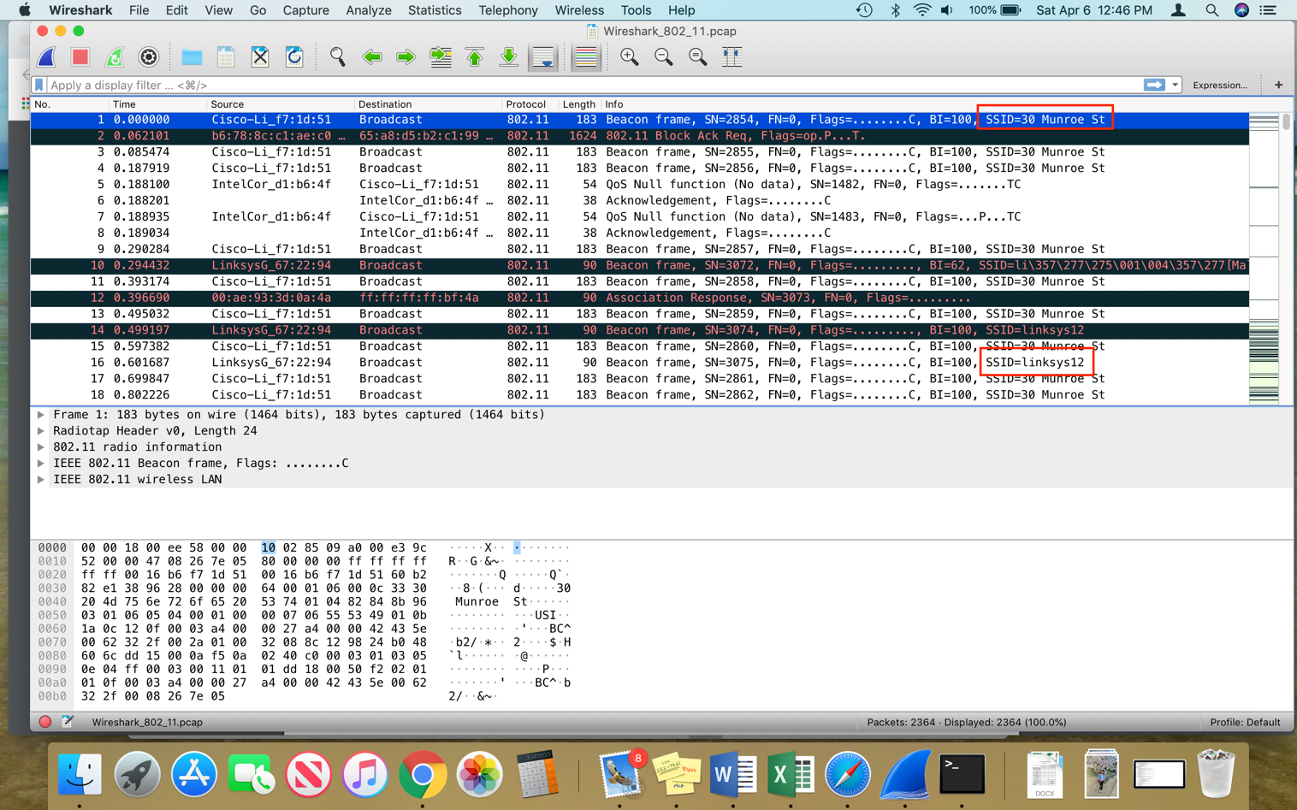The SSID of the 2 access points are *30 Munroe St* and *linksys12*.

1. What are the intervals of time between the transmissions of the beacon frames the linksys_ses_24086 access point? From the 30 Munroe St. access point? (Hint: this interval of time is contained in the beacon frame itself).

For the linksys_ses_24086 access point the time interval is .0554 seconds.

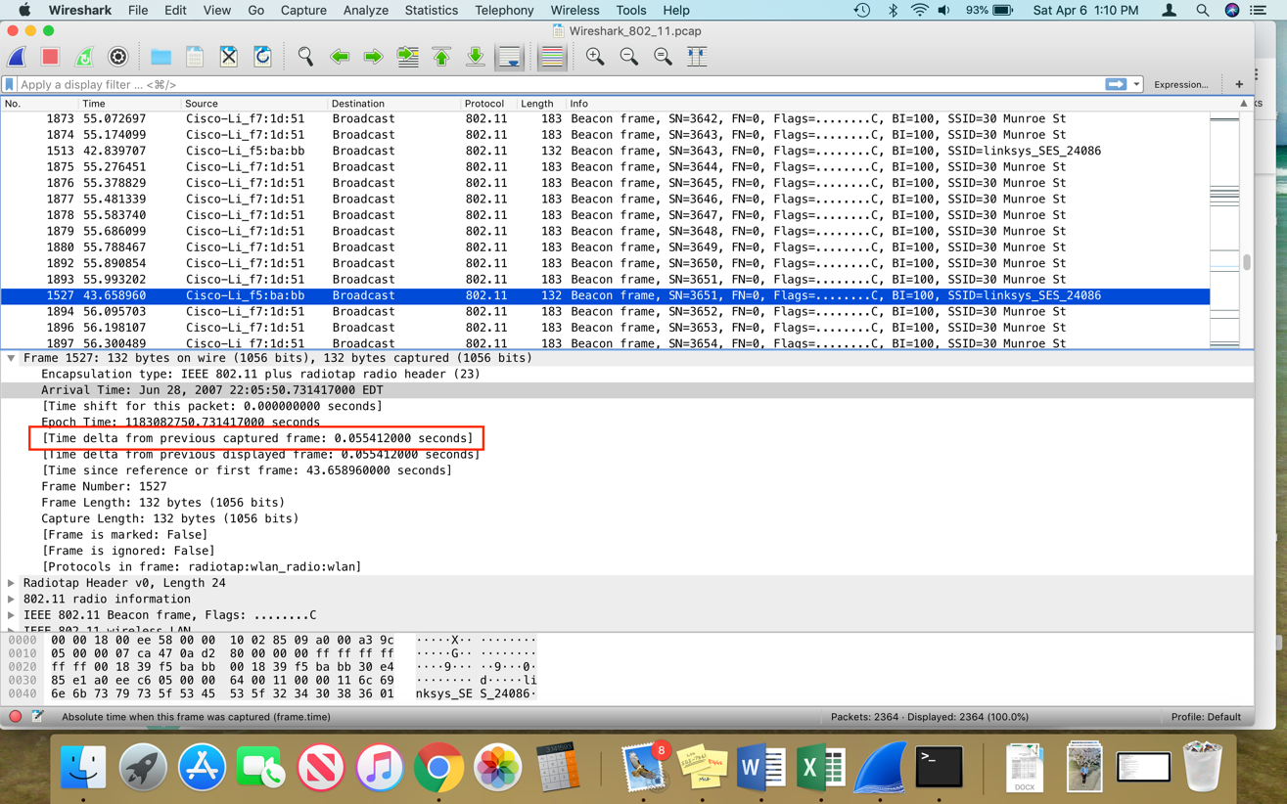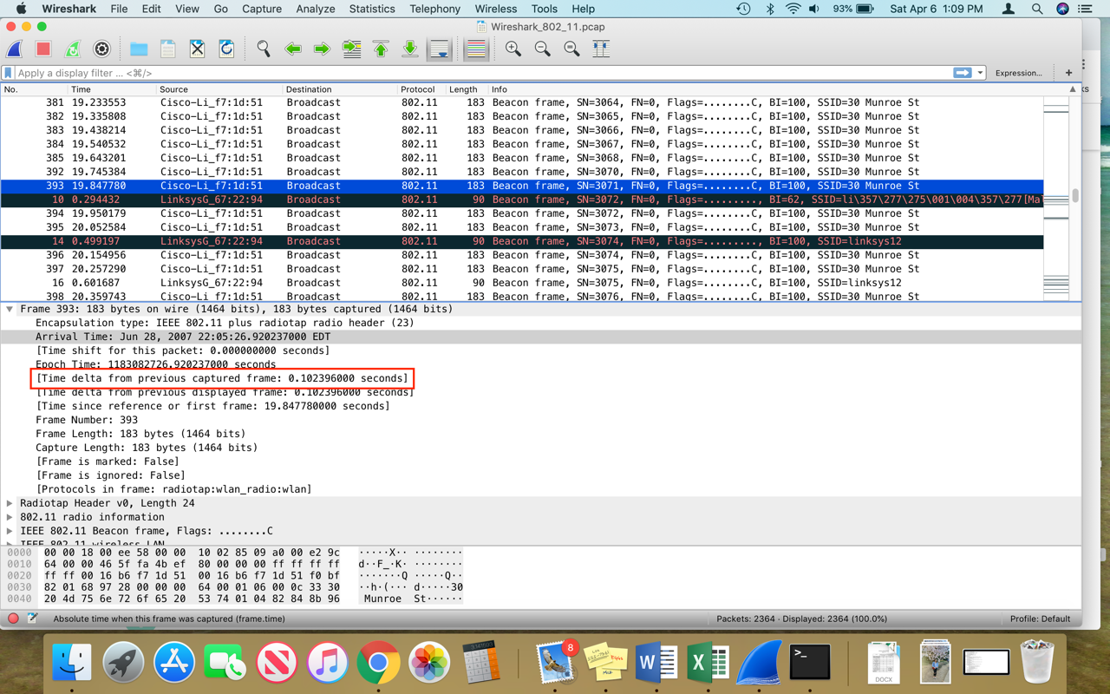For the 30 Munroe St. access point, it is .1024 seconds.

1. What (in hexadecimal notation) is the source MAC address on the beacon frame from 30 Munroe St? Recall from Figure 7.13 in the text that the source, destination, and BSS are three addresses used in an 802.11 frame. For a detailed discussion of the 802.11 frame structure, see section 7 in the IEEE 802.11 standards document (cited above).

The MAC Address of 30 Munroe St is 00:16:b6:f7:1d:51.

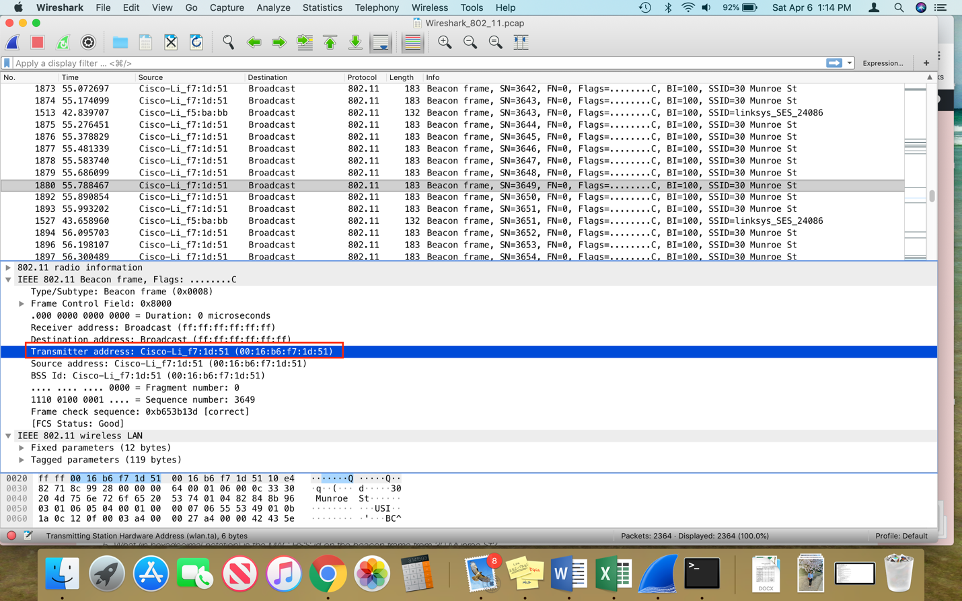

1. What (in hexadecimal notation) is the destination MAC address on the beacon frame from 30 Munroe St??

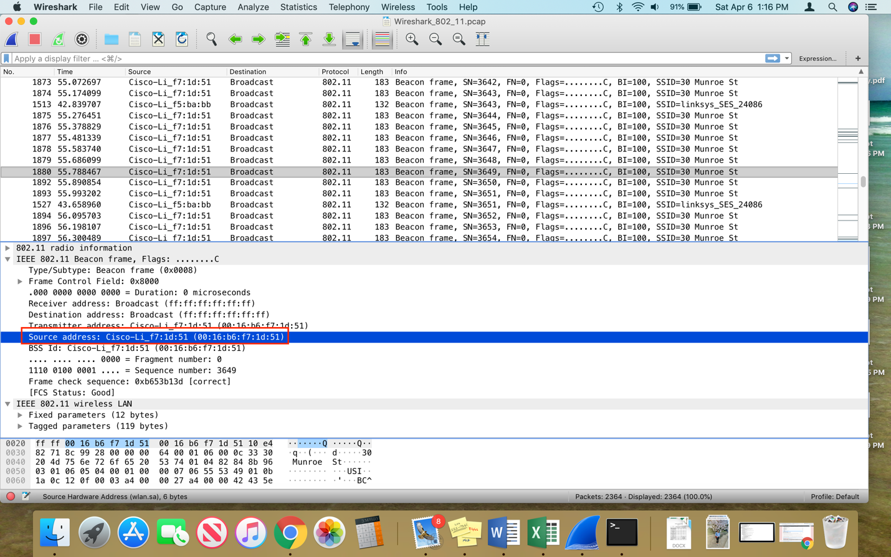The MAC Address for the destination is also 00:16:b6:f7:1d:51.

1. What (in hexadecimal notation) is the MAC BSS id on the beacon frame from 30 Munroe St?

The MAC BSS Id for 30 Munroe St. is also 00:16:b6:f7:1d:51.

